CourseLeaf Program Edits

Adding or removing a course from a program:

- Click “Edit Program”
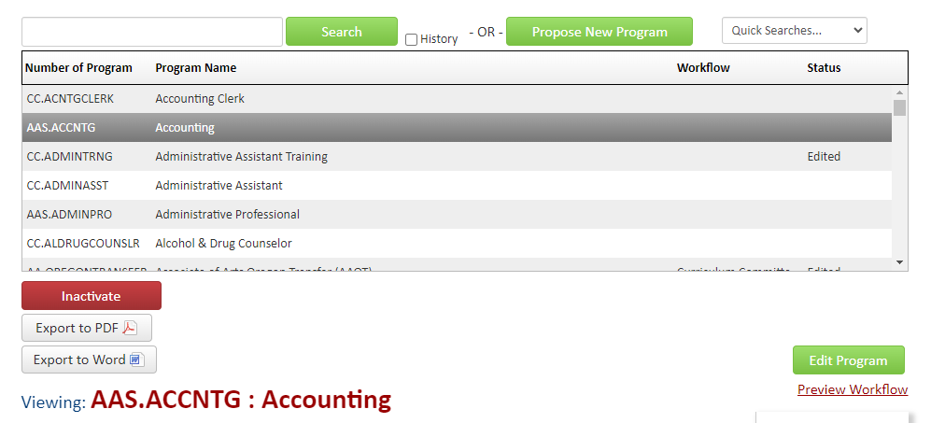

- Scroll down to “Proposed Curriculum”. Double click anywhere inside blue-outlined box. Usually the “Plan of Study Grid”, could also be the Electives list or something similar

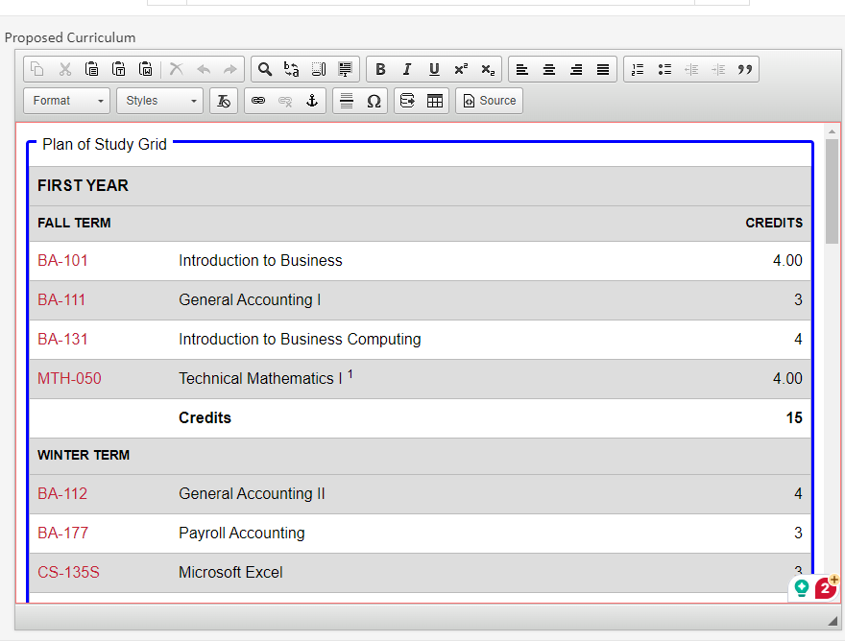

- Select the Year and Term from the dropdown list that you want to add/remove a course from.
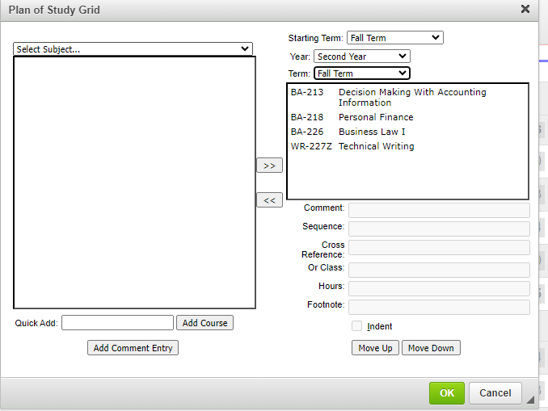

- To add an existing, approved course:
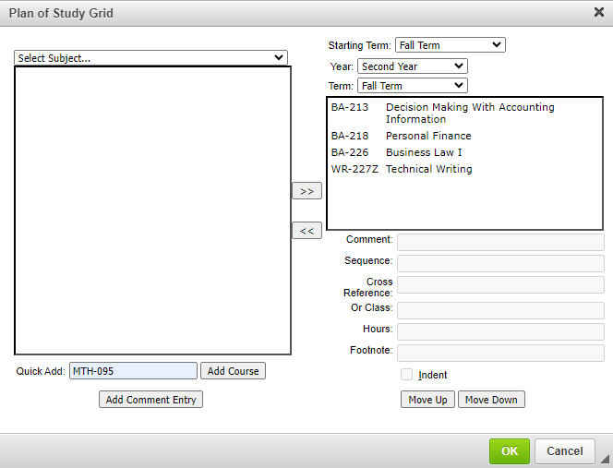
  - Option 1: Type the course name in the Quick Add box and click “Add Course”. The course name must be typed with the “-“.

  - Option 2: Use the “Select Subject” dropdown to select the subject. Select the course you want to add. Use the >> arrows to add the course.

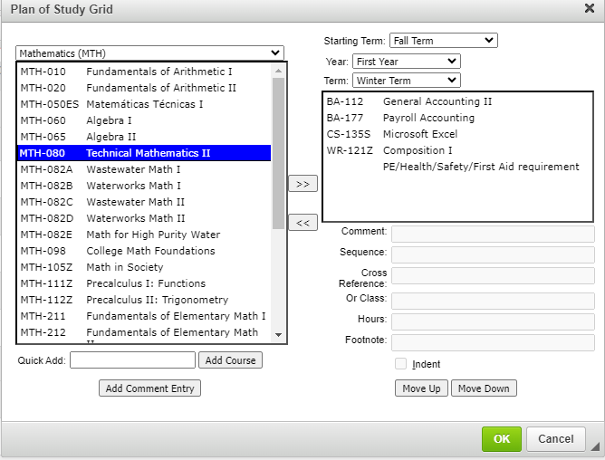

- To add a newly added, not-yet-approved course:
  - Type the course name in the Quick Add box and click “Add Course”. The course name must be typed with the “-“.
  - The course will show as “Course Not Found” until it’s approved.
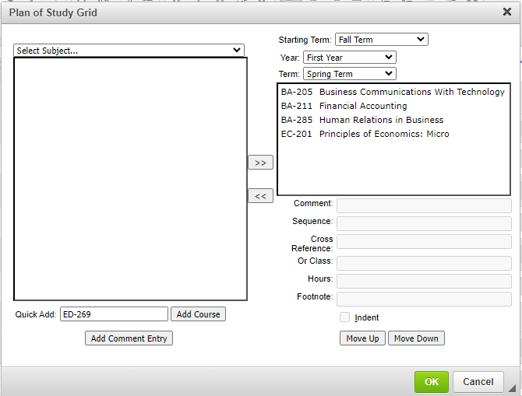

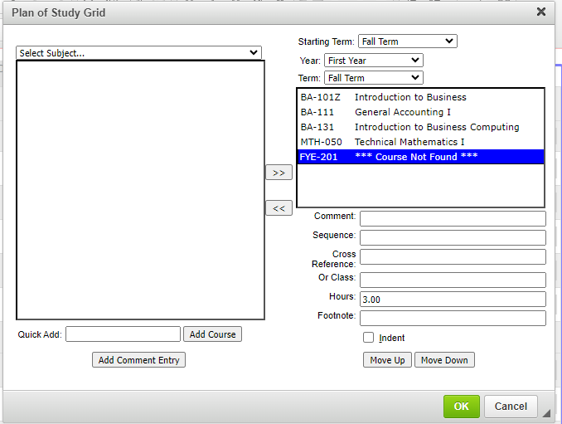
  - Enter the correct credits in the “Hours” box

- Use the “Move Up” and “Move Down” buttons to sort the course alpha-numerically within the term

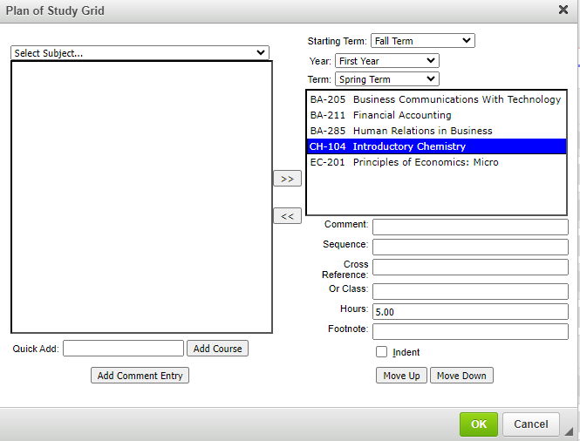

- To remove a course, select the course and use the << arrows to remove.

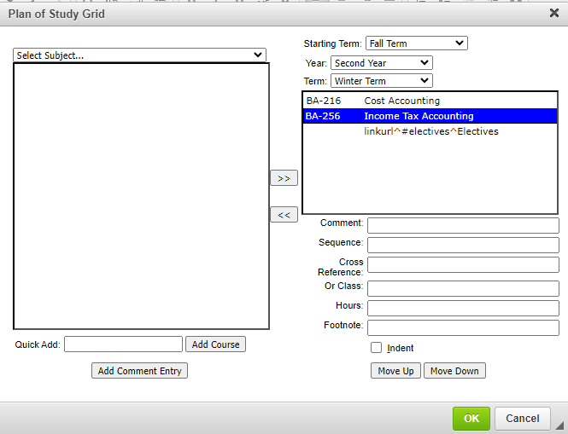

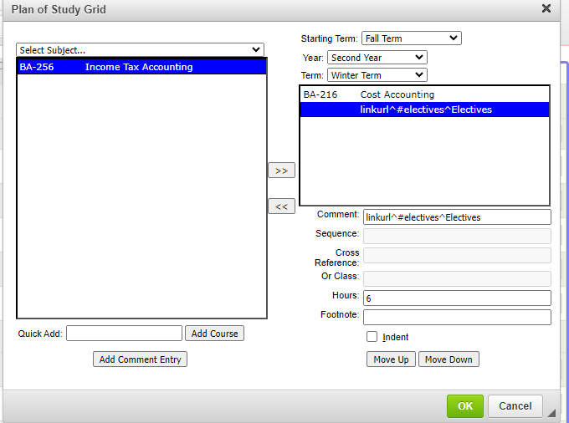

Adding an Elective List

- Click “Edit Program”

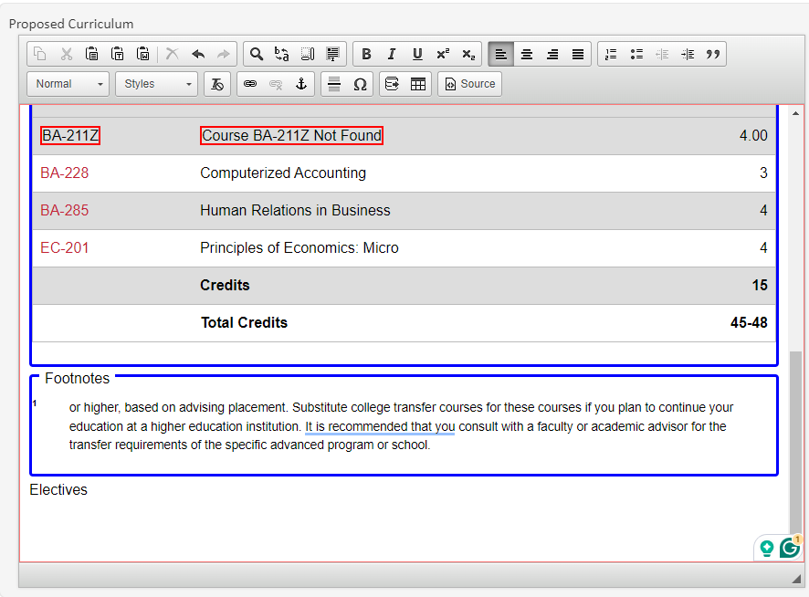
- Scroll to the end of the program, past the Plan of Study Grid. Type “Electives” in Normal Font.

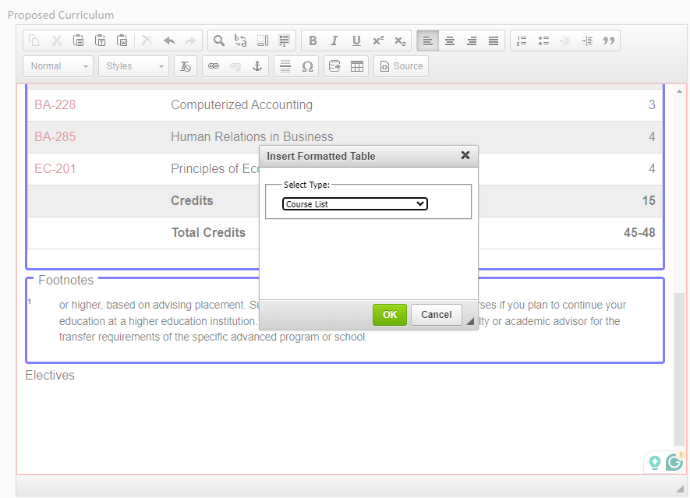
- Hit enter to move to the next line. Click the “Insert/Edit Formatted Table” button and select “Course List”. Click “OK”.

- Add courses using the instructions above.

- Double click or Highlight “Electives”. Change Style to “Header 2”
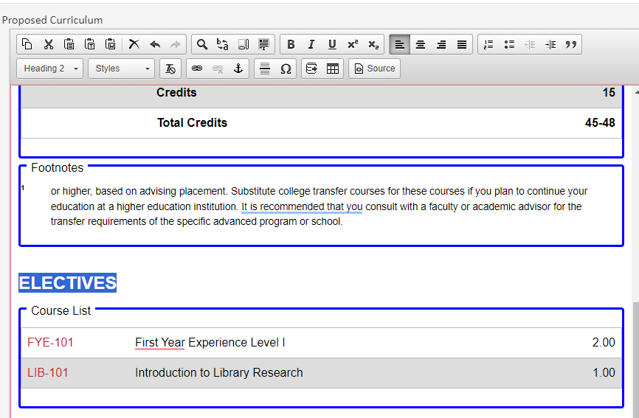

- Place your cursor directly before the word “Electives”. Select the “Anchor” tool. Type “electives” in the “Anchor Name” box and click “OK.”

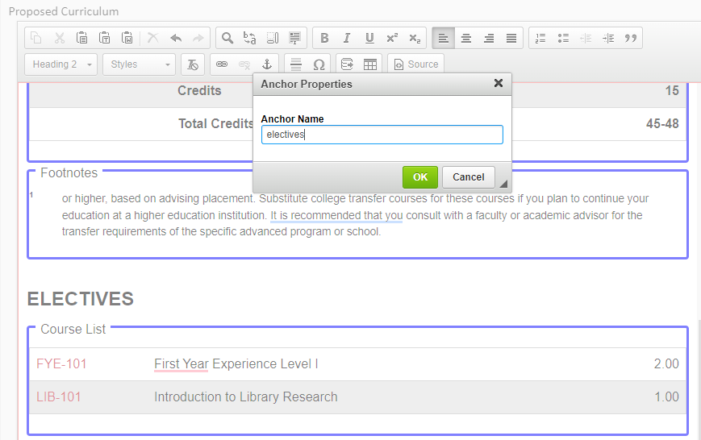

- This creates a place for the program to hyperlink to in the Plan of Study Grid.
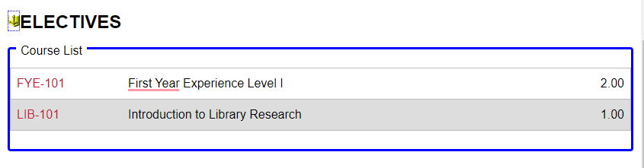

- Scroll back up to the “Plan of Study Grid” and double click inside the blue-outlined box. Select the Term and Year where you want to place Electives. Click “Add Comment Entry” and type linkurl^#electives^Electives. Click “ok”
  - The word after the hashtag must match the Anchor name exactly. The word after the second carat is what will show in the plan of study grid.

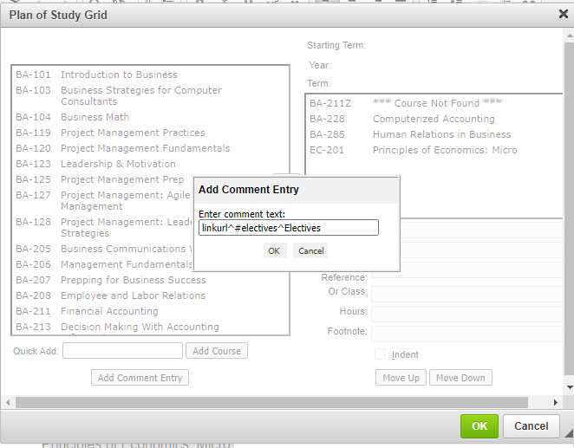
- Type in the required credits or range of credits in the “Hours” box. Use .00 after the credits. Click “OK”.
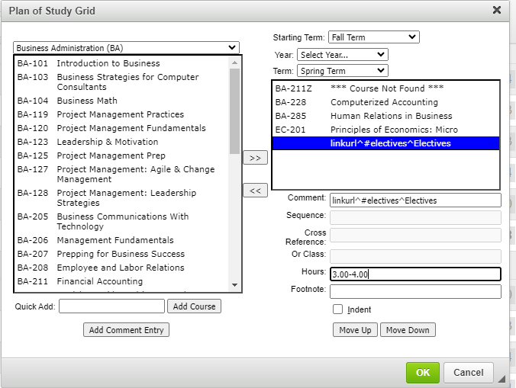

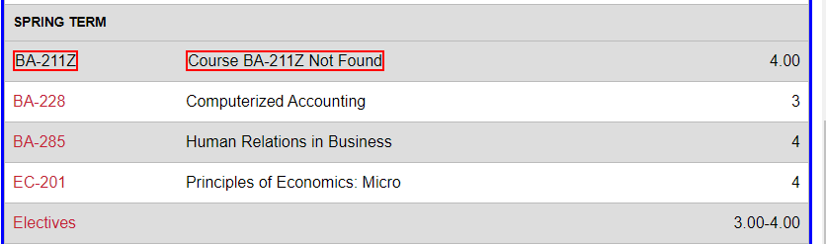
- This adds “Electives” to the “Plan of Study Grid” and will link to the Elective list below.

